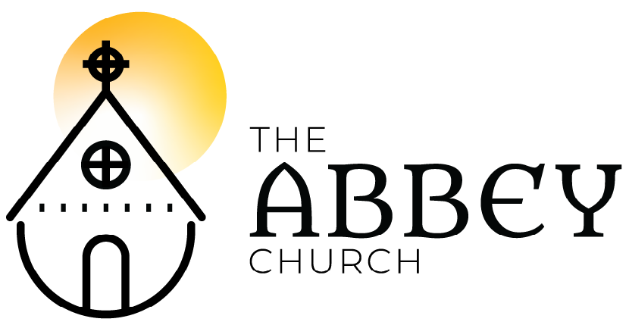
Easter IIa – April 19, 2020

Please submit your prayer requests in the YouTube chat or email to admin@emmauscommunity.ca to be included in prayers of people.

Welcome
Land Acknowledgment - Chivonne Graff
Bell x 3

Song/Reflection: Give Me Doubt
Give me doubt so I can see my neighbor as myself
Give me doubt so I can lay all my weapons on the ground
When the armor of God is too heavy for peace
Give me doubt, give me doubt, give me doubt

What be my courage now? My shield from evil?
Love, be my courage now - I shall not fear
Gungor/Arendt/Gungor – The Brilliance / CCLI

Opening Words
Alleluai! Christ is risen!
Christ is risen indeed, Alleluia!
The risen Christ meets us at the tomb, and turns our tears to joy. For your love and goodness
we give you thanks, O God.
Christ comes through our locked doors, and turns our fear to courage. For your love and goodness. - we give you thanks, O God.
Christ comes to daily life and work, and turns our failure to new vision. For your love and goodness
we give you thanks, O God.
Christ breaks the bread, and turns our despair to hope. For your love and goodness we give you thanks, O God.
As we rejoice in the gift of Christ’s risen presence with us we sing the Easter hymn.

Song: Now The Green Blade Rises
Now the green blade rises from the buried grain,
What that in dark earth many days has lain;
Love lives again, that with the dead has been;
Love is come again like wheat arising green.

In the grave they laid Him, love by hatred slain,
Thinking that He would never wake again,
Laid in the earth like grain that sleeps unseen;
Love is come again like wheat arising green.

Forth He came in triumph, like the risen grain,
He that for three days in the grave had lain;
Raised from the dead, my living Lord is seen;
Love is come again like wheat arising green.

When our hearts are wintry, grieving, or in pain,
Your touch can call us back to life again,
Field of our hearts that dead and bare have been;
Love is come again like wheat arising green.
Crum/Shaw 1928 Oxford Press / OneLicense

Poem: St. Thomas Didymus – By Denise Levertov, read by Catherine Pate (and image selected by her as well)

Collect

Reading: 1 Peter 1: 3-9 - Diane Bell

Song: Gospel Acclamation
Alleluia! Alleluia! Alleluia! (x4)
Reading: John 20: 19-31 – Jesse Robertson, ec
Alleluia! Alleluia! Alleluia! (x2)
Mass of Restoration / Josh Blakesley / OCP / OneLicense

Sermon: Melanie Ihmels / Silence

The Creed
I believe in God the Maker almighty,
Creator of heaven and earth; I believe in Jesus Christ, God’s only Son, our Lord. He was conceived by the power of the Holy Spirit and born of the Virgin Mary.

He suffered under Pontius Pilate, was crucified, died and was buried. He descended to the dead on the third day he rose again. He ascended into heav’n and is seated at the right hand of the Maker. He will come again to judge the living and the dead.

I believe in the Holy Spirit, the holy catholic Church, the communion of saints, the forgiveness of sins, +the resurrection of the body, and the life everlasting. Amen.
Ryan Flanigan, alt., © 2017, Common Hymnal, CCLI

Prayers of the People - Roxy Humphrey, EC

The Confession

Song: O Sons and Daughters
Alleluia Alleluia Alleluia!
O sons and daughters, let us sing!
The King of Heaven, the glorious King,
Over death today rose triumphing. Alleluia!
Alleluia Alleluia Alleluia!

That night th’apostles met in fear;
Amidst them came their Lord most dear,
And said, ”My peace be on all here.”
Alleluia! Alleluia Alleluia Alleluia!

When Thomas first the tidings heard,
How they had seen the risen Lord,
He doubted the disciples’ word. Alleluia!
Alleluia Alleluia Alleluia!
“My wounded side, O Thomas, see;
My hands, My feet, I show to thee;
Not faithless but believing be.”Alleluia!
Alleluia Alleluia Alleluia!

No longer Thomas then denied;
He saw the feet, the hands, the side;
“Thou art my Lord and God”, he cried.
Alleluia!
Tiserand 1494 Tr. Neale O Fillii Mode II. Public Domain.

The Peace
Prayer Over the Gifts

The Holy Eucharist:
The Lord be with you! And also with you
Lift up your hearts! We lift them to the Lord
Let us give thanks to the Lord our God.
It is right to give God thanks and praise…

Proper preface from the Book of Common
(occasionally: Glory to You forever and ever!)

The Sanctus:
Holy, holy, holy Lord
God of power and might!
Heaven and Earth are full of your glory. Hosanna in the highest. +Blessed is the one who comes in the name of the Lord. Hosanna in the highest.
---
The Memorial Acclamation:
Christ has died! Christ is risen!
Christ will come again!
Eucharistic Prayer adapted - St. Lydia’s Table, Brooklyn,

The Lord’s Prayer:
As beloved children of our loving Parent,
we pray as Jesus taught us: Our Father who art in heaven, hallowed be Thy name, Thy kingdom come, Thy will be done, on earth as in it is heaven. Give us this day our daily bread. And forgive us our trespasses as we forgive those who trespass against us. And lead us not into temptation but deliver us from evil. For thine is the kingdom, the power, and the glory. Forever and ever. Amen.

These are the gifts of God for the people of God, feed on Christ in your hearts through faith with thanksgiving. Amen.

Silence

Song: Little Things With Great Love
In the garden of our Savior
no flower grows unseen
His kindness rains like water
on every humble seed
No simple act of mercy
escapes His watchful eye
For there is One who sees me
His hand is over mine

In the kingdom of the heavens
no suffering is unknown
Each tear that falls is holy,
each breaking heart a throne
There is a song of beauty in every weeping eye
For there is One who knows me
His heart, it breaks with mine

O the deeds forgotten, O the works unseen
Every drink of water flowing graciously
Every tender mercy You’re making glorious
This You have asked of us:
Do little things with great love
Little things with great love

At the table of our Savior,
no mouth will go unfed
And His children in the shadows
stream in and raise their heads
O give us ears to hear them,
and give us eyes that see
For there is One who loves them.
I am His hands and feet
Assad / Wardell / Cunningham / Porter’s Gate – 2017 / Fair Trade Music Publishing / CCLI

Prayer After Communion

Song: Glory Bound
When I hear that trumpet sound
I will lay my burdens down
I will lay them deep into the ground
Then I'll know that I am glory bound
I'll be travelling far from home
But I won't be looking for to roam
I'll be crossing o'er the great divide
In a better home soon I will reside! Hallelujah

When I'm in my resting place
I'll look on my mother's face
Never more will I have to know
All the loneliness that plagues me so
So I'm waiting for that train to come
And I know where she's coming from
Listen can you hear her on the track
When I board I won't be looking back
Hallelujah
The Wailin Jennys/ Ruth Moody / Jericho Beach Records

Blessing

Sending:
Go in the peace and joy of the risen Lord!
Thanks be to God. Alleluia! Alleluia!

Postlude: I Still Haven’t Found What I’m Looking For (U2)

